TKR College of Engineering & Technology (Autonomous)
Department of Computer Science and Engineering
CSE-A | Batch A11 (CSE, Section A)
AutoSecAI: Autonomous Pull Request Analysis for Security, Vulnerability Detection, and Code Quality using Multi-Agent LLMs
(AutoSecAI)
S.No. | Student name | Roll / hall ticket no.
1 | CHEPURI RISHIVARDHAN | 23K91A0553
2 | BODA SANDEEP | 23K91A0539
3 | DHARAVATH SEETHARAM | 23K91A0562
4 | NARISIMHA REDDY | 24K95A0501
Under the guidance of: P. KISHORE, [DESIGNATION]
DESIGN AND IMPLEMENTATION
This document describes the design of AutoSecAI and how it was implemented: the architecture, the modules, the database schema, the API, key code walkthroughs, and the reasoning behind the main implementation decisions.

1 System Architecture
AutoSecAI is a single-machine application with two front doors and one engine. The engine is a Python package of 2,881 non-blank lines in fourteen modules that already existed when the project began: it parses changes, analyses them, scores functions, explains and patches findings, indexes repositories and writes reports. The first front door was a Streamlit page, which was left unchanged; in the final phase a thin FastAPI layer (502 lines), accounts and a React application (6,525 lines in 69 files) were added. The figure below shows the layers.
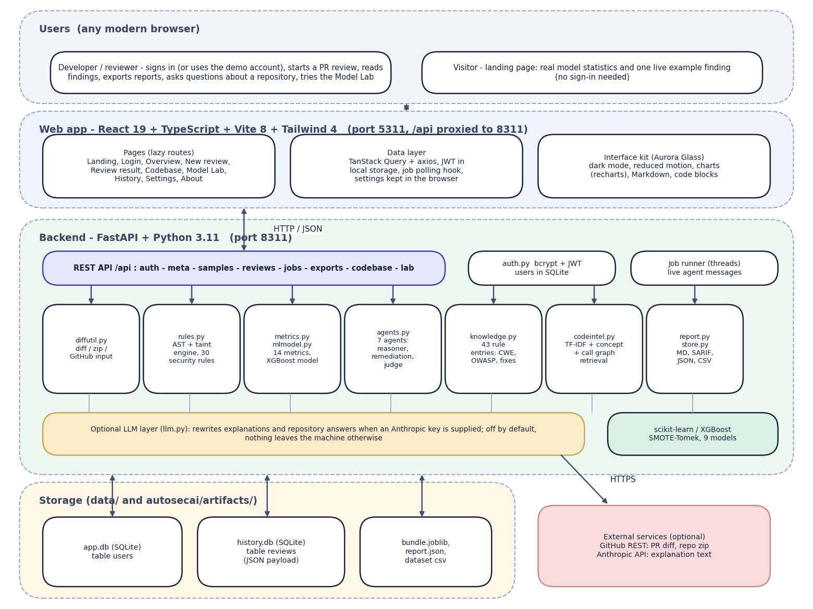
Fig. 1: System architecture of AutoSecAI
The diagram shows five bands. At the top are the users: a developer who signs in (or uses the seeded demo account) and a visitor who sees only the public landing page. Below is the React 19, TypeScript, Vite 8 and Tailwind 4 web application on port 5311, with lazily loaded pages, a data layer (TanStack Query and axios) that attaches the JWT and polls background jobs, and the Aurora Glass interface kit.
The backend band is a FastAPI application on port 8311. A REST layer exposes authentication, metadata, reviews, jobs, exports, the codebase assistant and the Model Lab; beside it sit auth.py (bcrypt and JWT) and the thread-based job runner. Beneath it are the seven engine modules that already existed: input handling (diffutil.py), the AST and taint rule engine (rules.py), metrics and model (metrics.py, mlmodel.py), the seven-agent pipeline (agents.py), the rule knowledge base (knowledge.py), repository retrieval (codeintel.py) and exporters and history (report.py, store.py).
The optional language-model layer (llm.py) is used only when an Anthropic key is supplied. Storage is local (app.db, history.db and the trained artefacts); the only external services are GitHub and, optionally, the Anthropic API.
Four principles shaped the design. Evidence before opinion: every finding is tied to a rule, a line and, where possible, an independent signal from the metric model, so that a reviewer can see why it was raised. Verify every fix: a patch is offered only after it has been applied to a copy of the source and the analysis has been run again. Keep the work local: parsing, analysis, model scoring and retrieval run on the user's machine, and the optional language-model layer is off by default. Say what is missing: when an input cannot support a result (for example a bare diff cannot yield a whole-file fix), the interface says so instead of hiding it.
The seven agents are deterministic software components that pass results through a shared trace; they are not language-model processes. The optional language-model text layer was not measured, and every result in this document was obtained without it.

2 Module Design
The table lists the modules with their real size, counted as non-blank lines of the files in the repository.
Table 1: Modules of AutoSecAI (non-blank lines)
Module | File | Lines | Responsibility
Input handling | autosecai/diffutil.py | 201 | Unified-diff parser, before/after diff, zip and folder reader (up to 1,500 files of 800 KB), GitHub pull-request and archive download, fix application and patch generation
Static analysis | autosecai/rules.py | 577 | Python AST analyser with taint levels, 30 security rules, quality rules, regex rules for JavaScript, PHP and Java, fix generators for SQL and shell calls
Rule knowledge base | autosecai/knowledge.py | 265 | 43 entries (30 security, 12 quality, 1 ML-derived) with CWE, OWASP, severity, explanation, impact, exploit sketch, fix and safe example; weights
Metrics | autosecai/metrics.py | 218 | The 14 source-code metrics per function from the Python AST
Corpus generator | autosecai/dataset.py | 143 | Generates the labelled Python corpus (8 vulnerability types, hard negatives, label noise)
Model | autosecai/mlmodel.py | 234 | SMOTE and Tomek links, seven feature selectors, nine classifiers, type classifier, ablation, persistence and prediction
Agents | autosecai/agents.py | 330 | The seven-agent pipeline, risk score and verdict
Codebase intelligence | autosecai/codeintel.py | 394 | Chunking, TF-IDF, concept detection, import and call graph, question answering, overview and onboarding guide
Reports and history | autosecai/report.py, store.py | 91 | Markdown, SARIF 2.1.0, JSON and CSV exporters; SQLite history
Optional LLM | autosecai/llm.py | 24 | Thin client used only when a key is supplied
Sample data | autosecai/samples.py | 230 | Demo pull request, before/after pair and demo repository
REST API | backend/main.py | 414 | 7 public and 18 protected routes, job runner, repository indexes, uploads, exports
Accounts | backend/auth.py | 82 | Registration, login, bcrypt, JWT, demo account
Web application | frontend/src | 6,525 | 69 TypeScript files: ten pages, review components, lab tabs, charts, interface kit
Original UI | app.py, autosecai/ui.py | 785 | Streamlit front end (unchanged, not run in the final tests)
Tests | tests/ | 133 | Engine and API tests

The dependencies run in one direction. The web application depends on the API; the API depends on the engine; the engine modules depend on each other in a simple chain (diffutil and rules feed agents; metrics feed mlmodel; knowledge is read by rules and agents). The engine has no knowledge of the API, which is why the Streamlit page and the API can coexist.

3 Database Design
Persistence uses SQLite through Python's standard library. Two files are used so that the account store, which belongs to the new web layer, is separate from the history store, which belongs to the original engine. A review is always read and written as a whole and is never queried field by field, so it is stored as one JSON document with a few indexed columns for the list view; this keeps the schema stable when the review structure grows.
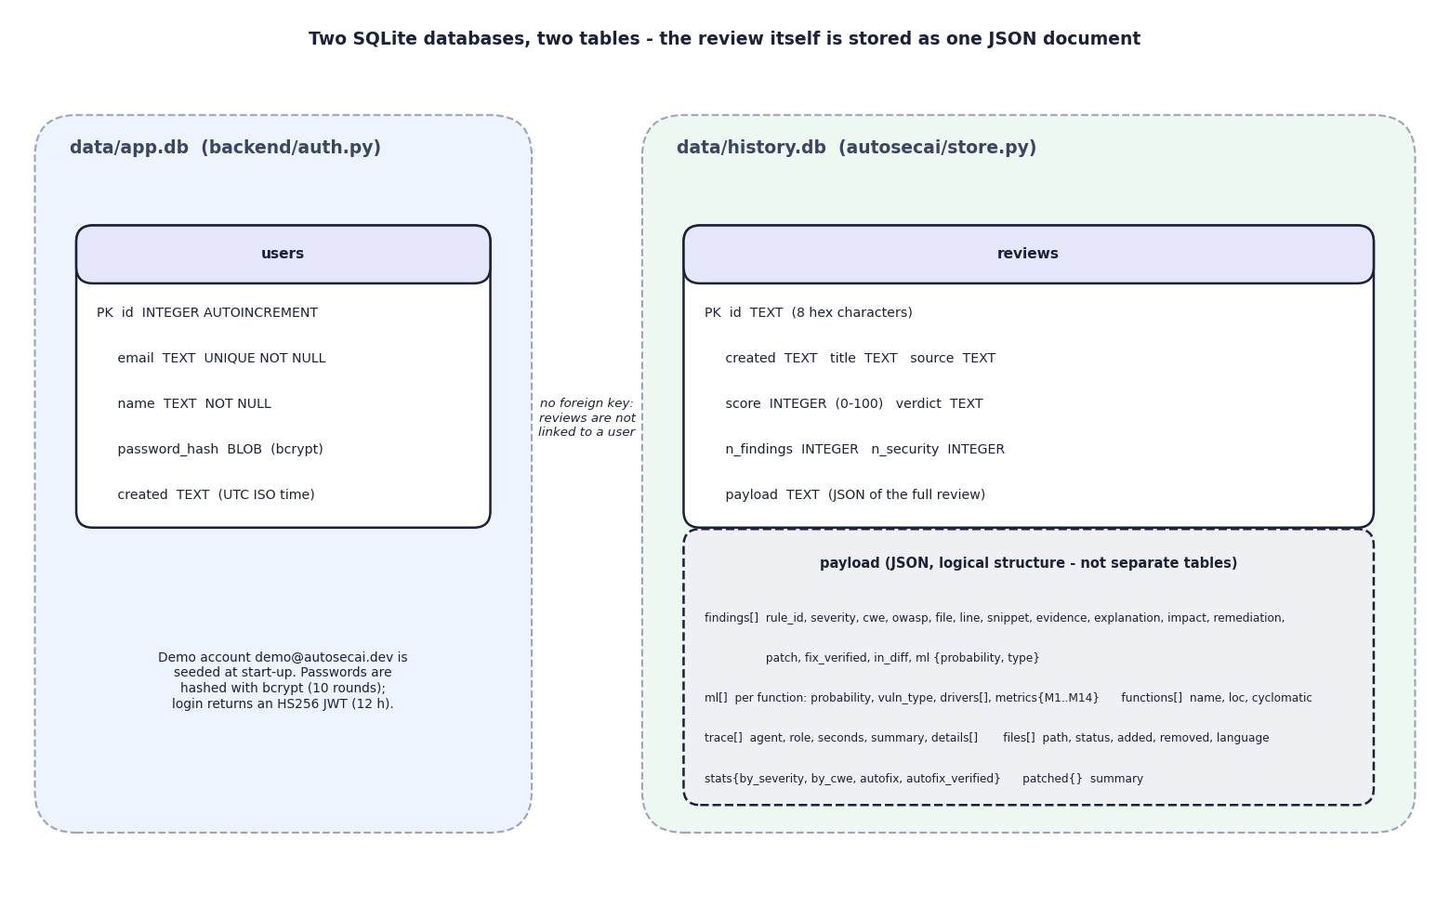
Fig. 2: Database design: two SQLite files
The file app.db holds one table, users (key, unique e-mail, name, bcrypt hash, creation time). The file history.db holds one table, reviews (eight-character identifier, creation time, title, source, score, verdict, two counters) and a payload column with the complete review as JSON. The lower box lists the logical parts of that payload (findings, ML rows, trace, files, statistics, patched files), which are not separate tables. The dotted note records a limitation: the tables are not linked, so a review has no user identifier and the history is shared by all accounts.
Table 2: Database tables and columns
File / table | Column | Type | Notes
app.db / users | id | INTEGER, primary key, auto-increment | Subject of the JWT
 | email | TEXT, UNIQUE, NOT NULL | Stored in lower case; format checked on registration
 | name | TEXT, NOT NULL | At least two characters
 | password_hash | BLOB, NOT NULL | bcrypt, 10 rounds; passwords cut at 72 bytes
 | created | TEXT, NOT NULL | UTC ISO time
history.db / reviews | id | TEXT, primary key | Eight hexadecimal characters
 | created, title, source | TEXT | Shown in the history table
 | score, verdict | INTEGER, TEXT | Score 0-100; APPROVE, REQUEST_CHANGES or BLOCK
 | n_findings, n_security | INTEGER | All findings; security findings inside the changed lines
 | payload | TEXT (JSON) | Findings, ML rows, trace, files, statistics, patched files, summary

The demo account is inserted at start-up if it does not exist. Deleting a review removes its row; there is no cascade because there is no relation. Two further stores exist in memory only: the job table (jobs older than one hour are dropped whenever a new job starts) and the table of repository indexes, which keeps the six most recently created indexes. Both disappear when the API process stops, which is acceptable because a job is short and an index can be rebuilt in milliseconds.

4 Application Architecture
The application has three tiers. The web tier is a single-page React application written in TypeScript and bundled with Vite. Pages are loaded lazily by route, server state is cached by TanStack Query, and an axios instance adds the bearer token to every request and redirects to the sign-in page on a 401. Long operations use a hook that starts a job, polls it every 350 ms and shows the agents' messages as they arrive. User settings (minimum severity, ML agent on or off, optional keys) live in the browser's local storage and are sent with each request; the server never stores them.
The API tier is a FastAPI application. Routes validate their input with Pydantic models, call the engine functions unchanged and return JSON; a helper replaces non-finite floating-point numbers, which JSON cannot carry. Reviews and the retraining run as jobs: start_job creates a record in the in-memory job table, runs the work in a daemon thread and stores either the result or a readable error. Repository indexes are kept in an ordered dictionary limited to six entries. The engine tier is the Python package; it has no knowledge of HTTP.
The trained model is loaded lazily and cached; if the artefacts are missing the first call trains them (about 32 s), and the Model Lab can retrain on request as a job.

5 API Design
The API has 25 route handlers: 7 public and 18 that require a bearer token. Paths are grouped by resource under /api, request bodies are JSON (except uploads, which are multipart), and errors have the shape {"detail": "..."} with a readable message. A review is created by an asynchronous call that answers 202 with a job identifier, because it can take longer than a request should; all other calls are synchronous. The interactive documentation of FastAPI is available at /docs on port 8311.
Table 3: HTTP endpoints of AutoSecAI
Method | Path | Access | Purpose
GET | /api/health | public | Liveness and version
GET | /api/public/stats | public | Model statistics from the stored report, for the landing page
GET | /api/public/rules | public | Titles of the security weakness classes in the knowledge base
GET | /api/public/example | public | One real finding from the demo pull request (computed once, not saved)
POST | /api/auth/login | public | E-mail and password to token and user; 401 on a wrong password
POST | /api/auth/register | public | Create an account (201); 409 for a duplicate, 422 for invalid input
GET | /api/auth/demo | public | The seeded demo credentials
GET | /api/auth/me | JWT | The signed-in user
GET | /api/meta | JWT | Version, severities, the seven agents, the 14 metrics with safe-function means, suggested questions
GET | /api/samples | JWT | Demo diff, before and after versions, demo repository file list
POST | /api/reviews | JWT | Start a review (kinds demo-diff, demo-versions, diff, versions, github, folder); 202 with a job id
POST | /api/reviews/upload | JWT | Start a review from uploaded files or zips (multipart); 202
GET | /api/jobs/{id} | JWT | Status, live messages, result or error of a job
GET | /api/reviews | JWT | List stored reviews (limit 1-500)
GET | /api/reviews/{id} | JWT | One complete review; 404 if it does not exist
DELETE | /api/reviews/{id} | JWT | Delete a review
GET | /api/reviews/{id}/export/{fmt} | JWT | Download md, sarif, json or csv
GET | /api/reviews/{id}/patched | JWT | Download one automatically fixed file (full-file input only)
POST | /api/codebase/index | JWT | Index the demo shop, this project, a folder or a GitHub repository
POST | /api/codebase/index/upload | JWT | Index uploaded zips
GET | /api/codebase/{id} | JWT | Overview, onboarding guide and graph of a loaded index
POST | /api/codebase/{id}/ask | JWT | Answer a question with cited locations (k limited to 1-12)
GET | /api/lab/report | JWT | The stored model report
POST | /api/lab/analyze | JWT | Metrics, probability, type and security findings for pasted code
POST | /api/lab/retrain | JWT | Retrain all models as a job; 202

6 Key Code Walkthroughs

6.1 Taint levels in the static analyser
The analyser assigns each expression a taint level: 0 for constants and sanitised values, 1 for a value built by string formatting, 2 for a value derived from a function parameter, and 3 for a value read from a request, the command line or standard input. The level of a compound expression is the highest level of its parts, and a call to a known sanitiser resets the level to 0. A sink such as cursor.execute is reported when its argument is string-built or its level is at least 2, and the confidence is high for level 3, medium for level 2 and low otherwise.
Listing: Taint level of an expression (autosecai/rules.py)
def _level_of(self, node, env, params) -> int:
if node is None:
return 0
if isinstance(node, ast.Constant):
return 0
if isinstance(node, ast.Name):
return env.get(node.id, 2 if node.id in params else 0)
if is_source_expr(node):
return 3
if isinstance(node, ast.Call):
d = dotted(node.func)
if d in SANITIZERS or d.rsplit(".", 1)[-1] in ("escape", "quote", "basename", "secure_filename"):
return 0
lv = max([self._level_of(a, env, params) for a in node.args] +
[self._level_of(k.value, env, params) for k in node.keywords] +
[self._level_of(node.func.value, env, params) if isinstance(node.func, ast.Attribute) else 0])
return lv
if isinstance(node, (ast.JoinedStr, ast.BinOp, ast.Attribute, ast.Subscript, ast.Tuple, ast.List, ast.IfExp,
ast.FormattedValue, ast.Dict, ast.Set, ast.Starred, ast.BoolOp, ast.UnaryOp)):
lv = max((self._level_of(c, env, params) for c in ast.iter_child_nodes(node)
if not isinstance(c, (ast.operator, ast.Load, ast.Store, ast.cmpop, ast.boolop, ast.unaryop))),
default=0)

6.2 Verified fixes
A fix is a replacement of a source segment with a start position, an end position and new text. For SQL calls built by string formatting, the fixer flattens the expression into literal parts and embedded expressions, replaces each expression by a placeholder, and returns the same call with the values as a parameter tuple. The remediation agent applies the fix to a copy of the source, re-runs the analyser and keeps the patch only if a finding of the same rule no longer appears within one line of the original. On the demo pull request all seven generated patches passed this check.
Listing: Rewriting a string-built SQL call into a parameterised one (autosecai/rules.py)
def sql_parametrize(call: ast.Call, ph="?"):
if not call.args or call.keywords or len(call.args) != 1:
return None
parts = _flatten_concat(call.args[0])
if not any(k == "e" for k, _ in parts):
return None
text, params = "", []
for i, (k, v) in enumerate(parts):
if k == "s":
text += v
else:
# strip quote chars around placeholders: '{x}' -> ?
if text.endswith(("'", '"')):
text = text[:-1]
if i + 1 < len(parts) and parts[i + 1][0] == "s" and parts[i + 1][1][:1] in ("'", '"'):
parts[i + 1] = ("s", parts[i + 1][1][1:])

6.3 Risk score and verdict
Listing: Scoring and verdict in the judge step (autosecai/agents.py)
floor = SEVERITY_ORDER[min_severity]
visible = [f for f in findings if SEVERITY_ORDER[f.severity] >= floor]
weight = 0.0
for f in visible:
if f.category != "security" and f.severity in ("info",):
continue
w = SEVERITY_WEIGHT[f.severity] * CONF_WEIGHT[f.confidence]
weight += w if f.extra.get("in_diff") else w * 0.15
score = round(100 * (1 - math.exp(-weight / 18)))
blockers = [f for f in visible if f.extra.get("in_diff") and f.category == "security"
and SEVERITY_ORDER[f.severity] >= 3 and f.confidence in ("high", "medium")]
mediums = [f for f in visible if f.extra.get("in_diff") and SEVERITY_ORDER[f.severity] >= 2]
if blockers or score >= 70:
verdict = "BLOCK"
elif mediums or score >= 30:
verdict = "REQUEST_CHANGES"
else:
verdict = "APPROVE"

fdicts = [finding_to_dict(f) for f in visible]
stats = dict(
by_severity={s: sum(1 for f in fdicts if f["severity"] == s and f["in_diff"]) for s in SEVERITY_ORDER},

6.4 Background jobs
The job runner is deliberately small. A new job removes jobs older than one hour, registers a record and starts a daemon thread. The thread's exceptions are converted into a message, so the interface always receives either a result or a reason.
Listing: Background job runner (backend/main.py)
def start_job(kind: str, work) -> str:
"""Run `work(tick)` in a thread; the UI polls /api/jobs/{id} for the agent messages and the result."""
now = time.time()
for k in [k for k, j in JOBS.items() if now - j["started"] > 3600]:
JOBS.pop(k, None)
job = dict(id=uuid.uuid4().hex[:12], kind=kind, status="running", messages=[], result=None, error=None, started=now,
seconds=None)
JOBS[job["id"]] = job

def run():
try:
job["result"] = work(job["messages"].append)
job["status"] = "done"
except HTTPException as e:
job["error"], job["status"] = str(e.detail), "error"
except Exception as e: # network / parsing errors surface as readable messages
job["error"], job["status"] = f"{type(e).__name__}: {e}", "error"
job["seconds"] = round(time.time() - now, 2)

threading.Thread(target=run, daemon=True).start()
return job["id"]

7 Implementation Decisions and Reasoning
The table lists the main decisions taken while building AutoSecAI, the reason for each and the price that was paid. Most of them follow one principle: every claim the tool makes about a pull request must come with evidence that a developer can check, and the tool must keep working on a laptop without any account or network.
Table 4: Implementation decisions
Decision | Why | Trade-off
Seven deterministic agents; a language model only rewrites text, and only if a key is supplied | Results are reproducible, testable and available offline; every finding carries a rule, a line, a CWE and a trace entry | Less flexible than a free-form reviewer; the optional language-model mode is not measured
Python ast with lightweight taint tracking instead of a full data-flow engine | About 1.23 ms per function, a source-to-sink explanation for every injection finding, and rewrites that can be re-scanned | Taint is followed inside one function and parameters are treated as tainted; flows across modules and unknown frameworks are missed
Regex rules for JavaScript, PHP and Java next to the Python engine | A pull request often touches several languages and a cheap check is better than silence | Higher false-positive and false-negative rates than the Python path
Python-AST adaptation of the base paper's 14 metrics, with M12-M14 added | The paper's code property graph is built for C; injection flaws in Python are better described by risky calls, string-built sinks and untrusted sources | Only M1-M11 mirror the paper; the added metrics are this project's own design
A generated corpus for the metric model | No labelled Python vulnerability data of suitable size was available, and the C datasets of the paper cannot be reused | Scores describe a generator, not real code; stated on every screen of the Model Lab
Own SMOTE and Tomek-link code (NumPy and scikit-learn only) | One dependency fewer and a transparent implementation that can be unit tested (test_smote_tomek_balances) | A simple version of the algorithms [15], [16], [17] that was not compared with a library
Production model chosen by held-out F1 (XGBoost), Random Forest kept for importances | XGBoost had the best F1 (0.851 against 0.826); Random Forest gives the importance chart of the base paper | Selection on the test set; the five-corpus study shows the ranking is stable but small differences are not significant
A patch is marked verified only if a re-scan no longer finds the same rule near the same line and the patched file still parses | A suggestion that does not remove the problem is worse than none | A re-scan proves the rule no longer fires, not that behaviour is preserved; the repository's own tests are not run
Risk score 100 x (1 - exp(-W / 18)); findings outside the diff count 15% | A bounded, saturating score; only lines changed by the pull request should block a merge | The constants were chosen by judgement, not fitted
Verdict from rules (a high or critical security finding in the diff blocks) as well as from the score | A single serious flaw must block the merge even when the score is moderate | Conservative: low-confidence high-severity findings do not block, but medium-confidence ones do
Reviews run as background threads polled by the browser | No broker to install; the interface shows each agent's message as it appears | The job table is in memory and is lost on restart; one process only
SQLite with one JSON document per review | A review is read and written as a whole; no migrations when a field is added | No queries inside findings and no owner column, so the history is shared by all accounts
A thin FastAPI layer over the unchanged engine; the Streamlit interface left in place | The engine and its ten tests were not touched; the API adds authentication, jobs and exports only | A second front end to maintain; the Streamlit version could not be run on the build machine
React 19 and TypeScript application from an interface kit (Aurora Glass) | Designed states for loading, empty and error cases, dark mode, reduced motion and keyboard use from the start; 22 scripted flows verify it | A larger dependency tree than the original interface
TF-IDF, concept words and an import / call graph for the codebase assistant | Works offline without downloading an embedding model; each answer lists why a location matched | Lexical: the expected file was first for 8 of 12 questions only
Local-first settings: the optional API key and token stay in the browser | Nothing leaves the machine unless the user turns the option on | Keys are visible to anyone with access to the browser profile

8 Security and Error Handling
Authentication. Passwords are hashed with bcrypt [28] (10 rounds, input limited to 72 bytes) and never stored or logged. A successful login returns a JSON Web Token [27] signed with HS256, valid for 12 hours; the signing key is the SHA-256 digest of the JWT_SECRET setting so that its length is always sufficient. Every route except the public ones depends on a function that validates the token and loads the user, and answers 401 with a specific message for a missing, expired or invalid token or a deleted account. Registration checks the name (two characters), the e-mail format and the password length (eight characters) and answers 409 for a duplicate address.
Input handling. Request bodies are validated by Pydantic models; invalid combinations (an empty diff, a folder that does not exist, a diff without files) answer 422 with an actionable message. A review is limited to 300 files; zip archives and folders are read up to 1,500 files of at most 800,000 bytes each; GitHub requests time out after 20 s (pull request) or 40 s (archive); repository questions ask for between 1 and 12 results; uploaded text is decoded with replacement characters so that binary content cannot raise an exception. The codebase index of the project itself excludes the front end, the documents, the scripts, the data folder and the environment file, so that secrets are never indexed. Cross-origin requests are allowed only from the two local front-end addresses.
Error surfacing. Failures inside a job (a bad GitHub link, a network error) are caught in the job thread and appear in the job record, from which the interface shows them with a retry option. Any other uncaught exception is converted by a global handler into a 500 response with the exception type and message. The interface has a distinct state for every case, including an unreachable API.
What is not protected. The history of reviews is not linked to users, so every account sees every review. Jobs and repository indexes are in memory and lost on restart. There is no rate limit other than the cost of bcrypt. The global error handler returns exception text, and the folder input reads any directory of the API host; both suit a local tool, not a server. The default JWT_SECRET is a placeholder, the demo credentials are published by a public endpoint by design, and tokens in local storage are exposed to any script injected into the page; the interface sanitises the Markdown it renders to reduce that risk.

9 User Interface Design
The web application has ten screens: the public landing page and the sign-in page, and, behind the sign-in, the overview, the new-review page, the review result, the codebase assistant, the Model Lab, the history, the settings and the about page, plus a friendly not-found page. A sidebar on wide screens and a drawer on phones give access to the sections, and a skip link lets keyboard users jump to the content.
The interface is built on a shared kit called Aurora Glass (translucent panels over a dark aurora background, with a light theme as well). Design decisions follow from the purpose of the product. The verdict is the first thing on a review page and uses both colour and a text label, so the meaning never depends on colour alone. Severities are shown as badges with their names. Every finding card expands to the explanation, impact, remediation, a safe pattern and, where one exists, a verified patch. Every asynchronous screen has a loading state, an empty state and an error state that says what failed and offers a retry; the 'API unreachable' case is covered by an automated test.
Four non-negotiable properties were applied to all screens: the theme (dark by default, light on request) persists across reloads; the reduced-motion setting of the operating system is honoured, and the animated pinned section of the landing page falls back to a plain list; every screen is laid out from 360 pixels upwards without horizontal scrolling (checked at 360 and 768 pixels in light and dark mode); and every control is reachable and operable with the keyboard, with a visible focus ring and Escape closing dialogs and the mobile drawer.
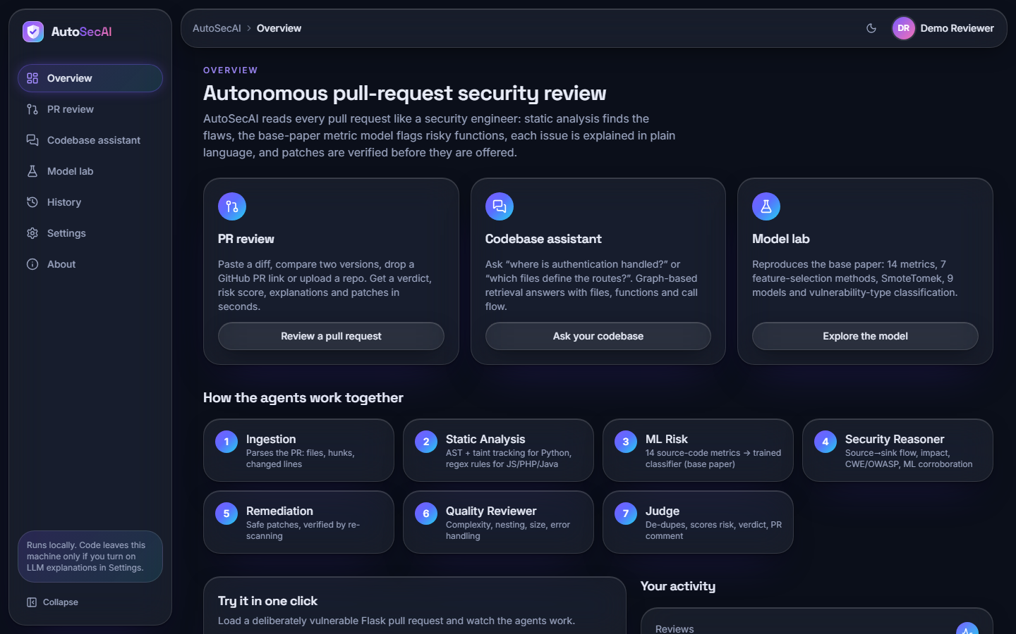  Fig. 3: Overview screen: three entry cards and the seven agents | 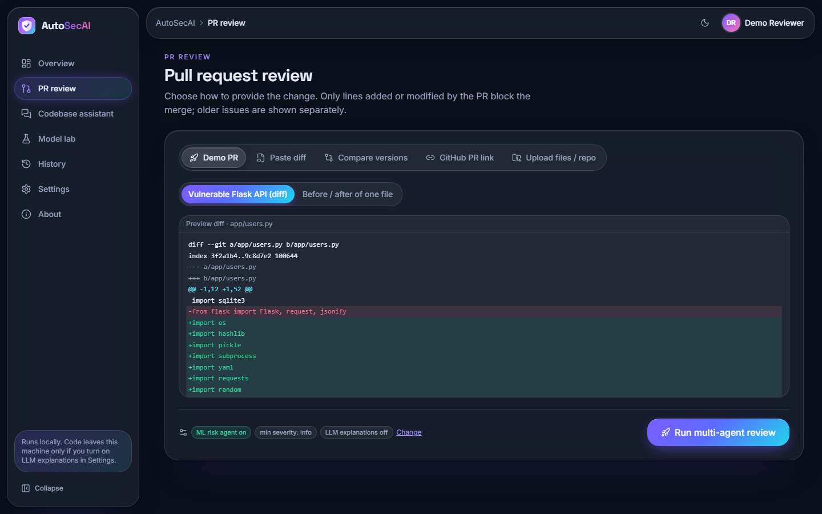  Fig. 4: New review screen with the five input modes

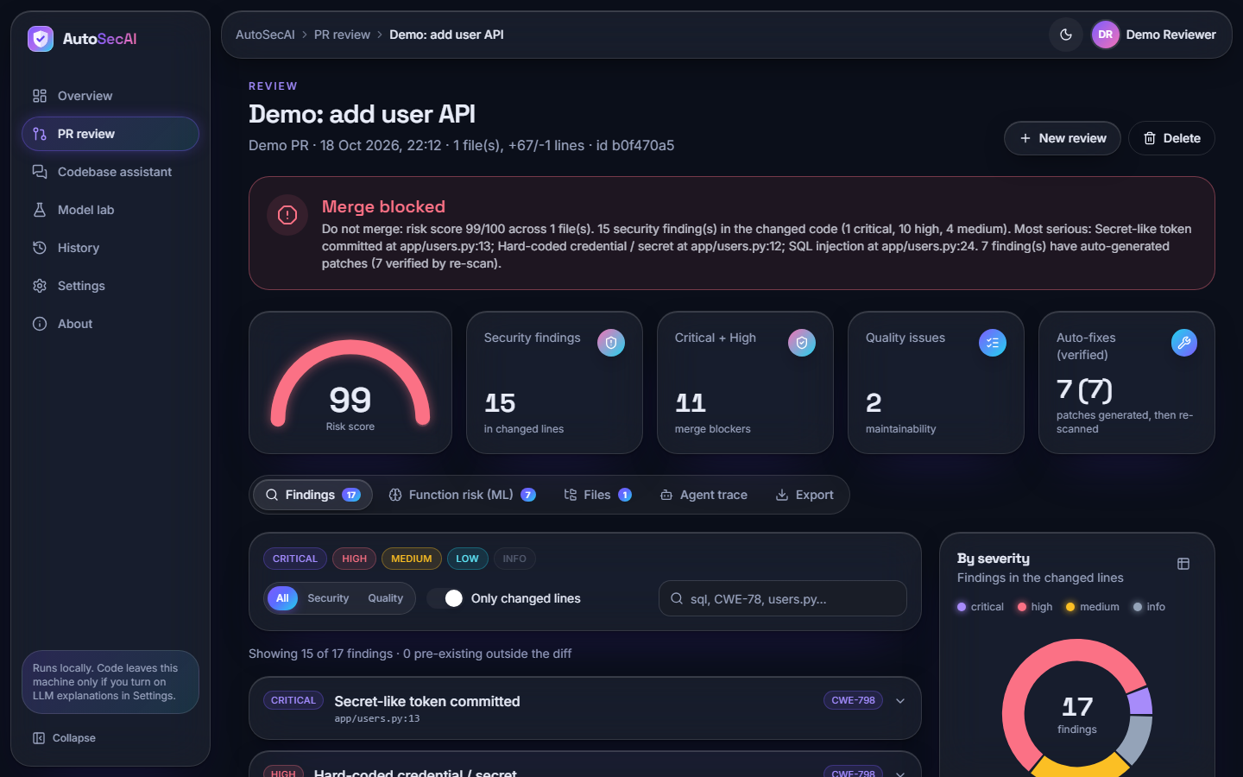  Fig. 5: Review result: verdict banner, gauge and four counters | 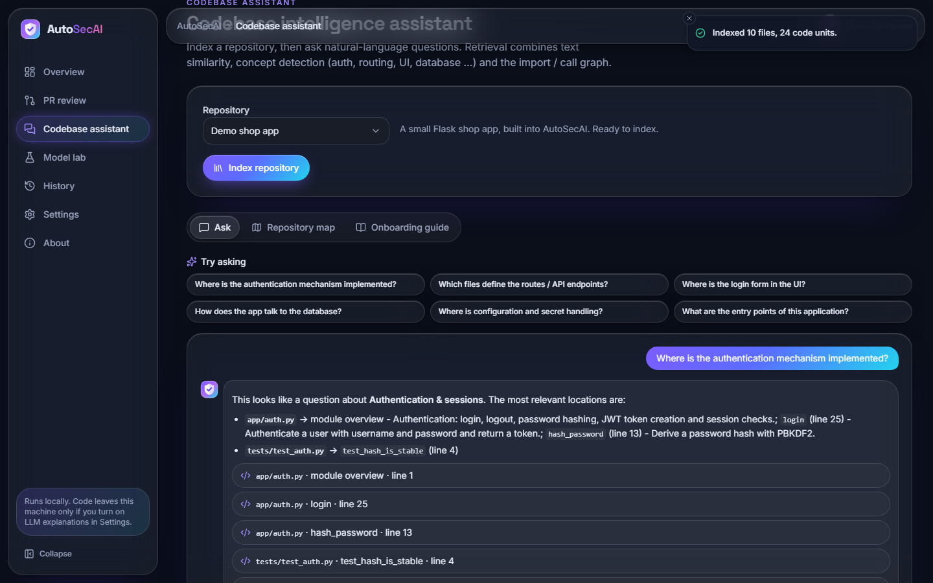  Fig. 6: Codebase assistant: suggested questions and a cited answer

The screens are shown in full size in the chapter on results and in the appendix of additional screens.

10 Installation and Execution
The product runs on Windows with Python 3.11 and Node.js. The ports are fixed in the .env file: 8311 for the API and 5311 for the web application. The sequence below was used for the final tests.
Table 5: Installation and verification commands
Step | Command | Effect
1 | run.bat | Reads the ports, installs the Python requirements, installs the npm packages when frontend/node_modules is missing, opens two windows (API and web) and then the browser at port 5311
2 | Press 'Use the demo account' | Signs in as demo@autosecai.dev with the password Demo@1234, or create an account on the same page
3 | Overview, 'Run demo pull request review' | Runs the seven agents on the built-in vulnerable pull request and opens the review
4 | python -m pytest tests -q | 17 engine and API tests
5 | python scripts/smoke_test.py | 16 checks against the running API
6 | python scripts/ui_flows.py | 22 browser flows with Playwright (needs playwright install chromium)
7 | python scripts/capture_screens.py | Rewrites the screenshots in docs/screenshots
8 | cd frontend && npm run build | Type-checks and bundles the web application

To run the parts by hand: python -m backend starts the API and npm run dev inside frontend starts the web application, which proxies /api to the API. The first start trains the models if the artefacts are missing (about 30 s). Anthropic keys and GitHub tokens are optional and are entered on the settings page. The original Streamlit interface is still started with run_streamlit.bat but requires streamlit and plotly, which were not installed on the test machine and therefore were not tested.

